
- Who Jarlaxle Really Is
  - Why JB is a Big Deal (Lore)
  - Key Facts
  - Philosophy and Principles
  - Appearance and Stagecraft
  - Bregan D’aerthe
- Running Jarlaxle in Your Campaign
  - What Jarlaxle Wants in Dragon Heist
  - His Web in Waterdeep
  - Ally, Rival, Patron, or Enemy
  - The Trust Games
  - Secrets, Lies, and Reveals
  - What He Knows and How He Knows It
- Key Scenes and When to Use Them (Homebrew)
  - Trollskull Intro Scene
  - Eyecatcher Reveal Scene
  - Shipwrights’ Ball Hooks
  - The Zardoz Betrayal Scheme
  - Operating in Skullport: Espionage and Beyond
- Silencing one of his Own: Elf Killer’s Demise
  - How Jarlaxle can frame an innocent man
and tie up loose ends with Soluun
- Combat and Reacting to Danger
  - Combat Philosophy, Not Just a Stat Block
  - Always have an Escape Plan
  - Combat Guide (Combos and JB’s Strategy)
- Piecing it Together: Useful Jarlaxle Info Plot Hooks Scattered Throughout WDH
  - What is Smokepowder? (Hint: Not gunpowder.)
  - Using Gunslingers and training with guns
  - Where are all the Smokepowder stockpiles?
  - JB’s Xanathar Spy, N’arl
  - Big Belchy, do we really need another submarine?
  - Zelifarn the Dragon and JB’s submarine
  - Need-to-know info on his 3 ships (Eyecatcher, Heartbreaker, Hellraiser)
Appendices
- Example scenes (dialogue, box text) for JB intros and reveals
- French/Drow phrases and accent tips
- Jarlaxle’s Many Magic Items (Censored Player-safe versions included)
- Understanding Jarlaxle’s Stat Block

Part 1: Who Jarlaxle Really Is
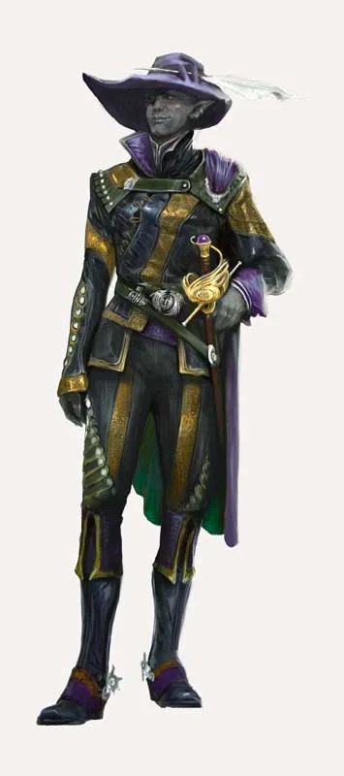
The Truth
Jarlaxle Baenre is not a villain. He is a man of opportunity.
He will oppose the characters only when their goals clash with his own, and he will happily become their most powerful ally the moment cooperation becomes more profitable. He does not die for gold. He does not fight fair. He does not commit unless the outcome benefits him, his people, or both.
Even if, somehow, Jarlaxle “loses” in your campaign, he still walks away with leverage, information, and/or influence. This makes him uniquely dangerous.
Unlike Manshoon, he is not chasing domination. Unlike the Xanathar, he is not crippled by paranoia. And unlike the Cassalanters, he is not desperate or on a time crunch.
Jarlaxle plays the long game, and he plays it smiling, enjoying every moment of it. His life’s work has been playing these games, and he should feel like the one villain your characters must fear, despite the paradox of him also being one of the best allies.
If you run him correctly, the party should never be sure whether they just won…or were allowed to win.

A Brief History Lesson: Why Jarlaxle Is a Big Deal
Jarlaxle Baenre is one of the most important non-player characters in all of the Forgotten Realms. He was created by R. A. Salvatore and introduced in the Legend of Drizzt novels, where he quickly became a fan favorite due to his charisma, humor, moral flexibility, and sheer survivability. Across decades of novels, Jarlaxle has survived betrayals, assassinations, divine politics, surface wars, Underdark purges, and alliances that would have killed lesser schemers.
In the books Jarlaxle frequently steals scenes and/or the spotlight from the protagonist himself. That protagonist in the books, of course, is Drizzt Do'Urden, arguably the most famous character in D&D history. And yet, many readers will still admit that Drizzt may be the hero, but Jarlaxle is their favorite. Why? Because he’s got style and panache, and more magical gadgets than medieval Batman (no, really; Salvatore has said he wanted him to have Batman levels of gadgets at his disposal).
Jarlaxle is also a maverick, a nonconformist. He’s “not like the other girls”, ok?
He is a drow who rejected Lolth yet evades her wrath, who leads Bregan D’aerthe, a mercenary band of male drow who were never meant to live, let alone thrive. In drow society, third-born sons are sacrificed to Lolth shortly after birth. Jarlaxle was a third son of House Baenre, the most powerful house in Menzoberranzan, and yet he survived when they tried to kill him in a divine intervention. He might not be a Chosen of Mystra, but he sure is one lucky guy as some god of fate seems to be protecting him. Which should make him very difficult to kill, if we’re trying to portray him right.

Celebrity Status
Dragon Heist deliberately features “celebrity NPCs” from across the Forgotten Realms: Laeral Silverhand, Manshoon, Xanathar, Volo, Vajra, etc. When the players meet him, have them do a History check with a low DC (i.e. 5) to recognize his name, and a 15 to know most of his legendary exploits. They may not know the exact details (maybe a Nat 20 would make them a fanboy / history buff) since there are so many tales and the facts have been warped through games of telephone, but they do know he’s a big deal.
Key facts about JB:
Race: Drow (dark elf)
Hairstyle: Bald (this is important, in Drow culture hairstyle indicates status, so a bald man rejects societal norms)
Alignment: Chaotic Neutral
Affiliation: Bregan D’aerthe (founder and leader)
Birthplace: Menzoberranzan, largest city in the Underdark
House: Baenre, but he left his house and name to escape the stifling drow matriarchy and forge his own path.
Notable allies: Artemis Entreri, Drizzt Do’Urden (sometimes an ally sometimes an adversary)
Origins and rise: Born to Matron Mother Yvonnel Baenre of House Baenre (the biggest and baddest house in the Underdark), Jarlaxle narrowly escaped being sacrificed to Lolth, a fate typical for male drow infants. Rejecting Lolth’s dogma, he gathered dispossessed male drow to form Bregan D’aerthe, a mercenary brotherhood that sold its services to the highest bidder. The group’s independence and effectiveness made Jarlaxle a powerful yet unpredictable force in drow society.

Core Personality and How to Roleplay
Jarlaxle is a confident swashbuckling leader and an opportunist businessman with cutthroat methods, but he is not heartless. He has survived his rough upbringing by being clever, adaptable, and indispensable. He may be an agent of Chaos but he does have strong principles regarding freedom and liberty from oppression. When he plays Zardoz Zord you can see this aspect of him apply to his sympathy for the small folk, the poor or disenfranchised members of Waterdeep because he knows what it’s like to grow up in a society that has no place for him despite his talents.
LIBERTY AND THE LORD’S ALLIANCE
For this reason he despises Lolth and the society she created and he still bears scars from that upbringing that will never heal. He doesn’t have hope for the Underdark society to change, which is why he feels like he must create a sanctuary for all of his fellow male drow who made their exodus with him. He is a shepherd but his men are anything but sheep. He has already infiltrated Luskan to make it a sanctuary city, but he knows that their protections are fragile if the matriarchy ever found out and hunted his people down. Therefore, he is adamant to curry favor with the Lords of the Lords Alliance, with their most important member being none other than Laeral Silverhand.
JARLAXLE’S ACCENT
I think the go-to voices for Jarlaxle are either an ultra-cocky forever-inebriated pirate (think Jack Sparrow), or a sophisticated French accent given the hints of French flair in names like Bregan D’aerthe.
I elected to go with the French accent channeling my best mix of The Merovingian from the Matrix and the French nudist (Skuba King) from Along Came Polly, but you do you. I saved the Jack Sparrow for when he was in disguise.
You could even throw players a massive hint that he is disguised as someone like Laeral while sounding like a drunk pirate, but I chose to have him only disguise himself as people he could imitate well so his accent wouldn’t bleed through unless he was actually legitimately inebriated (i.e. too much wine at the Shipwright’s Ball, etc)..
Purposely making Jarlaxle stumble over certain words in his French accent (like a character whose name start with an “h”, which is not pronounced in French) - only to reveal to them later that he really could pronounce those sounds all along, he just chooses not to pronounce them correctly.
There are actually quite a few French phrases that your English speaking players might already know since a lot of them are used in American vernacular. For a list of phrases that are likely to come up in your campaign, check Appendix B.

THE PIVOT KING (AGENT OF CHAOS)
Jarlaxle does not succeed because his plans are perfect. He succeeds because he pivots better than anyone else in the room.
When something goes wrong, don’t panic; smile. Let him improvise. That is his superpower. If your players derail your prep, Jarlaxle should feel like the one NPC who thrives on that chaos.

Philosophy and Principles
Jarlaxle lives by his own personal code:
- Pragmatism & Value over Faith & Loyalty
- Opportunity Trumps Dogma. Chaos is a Ladder.
- The enemy of my enemy is my friend with mutual benefits
- Never be the obvious threat. Always have a Plan B. Think 3 steps ahead.
Jarlaxle believes chaos is not a pit, but a ladder. Not because chaos is noble, but because chaos creates openings. Jarlaxle does not push people off the ladder. He offers to hold it steady… for a price.
He does not want to rule openly either, he only wants Luskan to receive favor for his deeds, he isn’t interested in direct fame. He wants to be indispensable and therefore will do whatever it takes to show he is invaluable to the leaders of the Lords Alliance cities.

Why He Was Chosen as a “Villain”
Jarlaxle was chosen as one of the four Dragon Heist antagonists because he’s the master of faction wars, which thrive on information brokering and political intrigue .
That tension is the point.

Jarlaxle Always Keeps His Cool. (Example from our Campaign)
If accused of something he deflects, denies, or uses humor to feign ignorance.
Jarlaxle also rarely threatens directly. He implies consequences through insight.
For example, when I first introduce Jarlaxle in the Trollskull Manor, he has clearly:
A.) Committed a B&E (Breaking and Entering)
B.) Drugged their alchemist buddy, Duegal, to pass out
C.) Took their best wine from storage and drank it.
All without being detected by Lif the Ghost and Volo who was supposed to be keeping an eye on a comatose Nat (to be fair he isn’t the most perceptive wizard).
When my player, Tzarafar, is first to arrive, alone he is intimidated and exhausted. JB has waited for this exact moment when the party is too low on resources to fight him.
When Tzar tells him to leave, he invites the little kobold to sit down and have a drink with him. When Tzar realizes he is outclassed through an easy history check of the infamous pirate Jarlaxle sitting in his bar, he knows he won’t win the fight. He accuses him of breaking and entering but Jarlaxle says he hasn’t broken anything and the door was unlocked and the windows were open (blown out by a fireball) He tries to get help in the basement but he finds Duegal won’t wake up, Jarlaxle has slipped a drow sleeping powder in his drink. When Tzar tells him to leave, JB says he hasn’t finished his drink. Tzar takes the drink from his hands, downs it, and tells him his drink is finished so he needs to leave. But, taking a page from the Dread Pirate Robert, JB has actually poisoned both glasses with drow poison (to which he has an immunity). Tzar fights off paralysis and decides to simply sit down and wait for his party to arrive. When he opens his eyes Jarlaxle is gone (but he is actually just invisible, waiting for the rest of the party to arrive so he can explain his Zardoz Betrayal Pitch to everyone). At no point does Jarlaxle admit his wrongdoing with drugging Tzar. He jokes he’s had too much wine and his little kobold body can’t handle his booze. He does the same with Duegal.
When the party accuses him of breaking in, he says he simply came to check out the Trollskull since he heard it was opening up soon and he’s a drow so it’s not that late at night for him, and he’s interested in investing in them (a double meaning since he is interested in partnering with them for heists, not the Trollskull per se).
He remains relaxed at all times, even when surrounded by the party. His confidence speaks volumes to the party about his threat level, and his cheekiness and slippery wordplay means they won’t be able to frame him for anything or record him for any sort of blackmail. They’ll have to play his games. Games which he excels at.

Part 2: How to Run Him in Dragon Heist

What Jarlaxle Wants
At a glance, Jarlaxle appears to be chasing the same prize as everyone else, the dragons (gold coins) found in the Vault of the Dragon. He is not. Sure, money is nice, but what he wants is influence and power.

His Real Goals:
- Secure Luskan’s place in the Lords’ Alliance
  - This is personal for JB. Luskan is his greatest long con and he doesn’t have the numbers for conquest, so getting the rulers of the most important cities will pay far more dividends.
  - To accomplish Goal #1, he wants to return Dagult Neverember’s gold to Waterdeep. Not to keep it. To prove his own legitimacy, responsibility, and influence. Gold going back to the city buys more power than all of it going to him.
  - The Staff of Ahgairhon
    - Upon learning of the Staff also being kept in the Dragon’s Vault, he may decide to use this as leverage (assuming someone like Manshoon doesn’t try to nab it, as Manshoon would likely be interested in this above all else)
    - The owner of the staff controls the Dragon Ward over the city, and if things go south and he doesn’t get the credit he feel he is disturbed, he make blackmail Laeral and/or Vajra with threat of letting dragon (i.e. the nearby Claugiloyamater in the Kryptgarden forest) access to fly over the city
- Establish a permanent intelligence foothold in Waterdeep
  - Nimblewright surveillance on noble gossip, tavern whispers and secrets of the Undermountain, Dockside secrets shared between sailors in Mistshore. The Bregan D’aerthe is a spy network and he is an information broker, with Waterdeep being a key hub for his main trade (information).

Why He Only Wants a Small Share of the Gold
This is not generosity, it’s optics. Jarlaxle understands something most villains do not: power comes from being seen as useful, not feared. Like Manshoon, he is not hurting for wealth, he has money. What he needs is power, influence, and favors. Most people struggle to stay useful because it is exhausting, but JB never tires of playing the Game.

The Web He Weaves in Waterdeep
Jarlaxle never approaches the party directly at first. He watches and learns their values, habits, strengths and weaknesses, and their tactics should they ever double cross him.

Jarlaxle’s Eyes and Ears:
- The Sea Maidens Faire - His ships are moving safehouses, rumor mills, and exit strategies disguised as spectacle.
- Nimblewrights - Purchased, placed, and sold through Zardoz Zord.
(See the Zardoz Guide for the Ledger of Automata.)
  - My personal homebrew is that he can also override them as sleeper agents to act in his interests (i.e. backstabbing the Gralhunds to steal the Stone of Golorr)
- Dockworkers and performers
  - Remember: Some of his performers aren’t a part of the Bregan D’aerthe but ALL of his subordinates gather excellent intel for him. People tend to drop their guard around his carnies
- Adventurers who think they are clever
  - By hanging out at the Yawning Portal and Frewn’s tavern (as JB Nevercott) he can keep an eye on the party from the get-go and introduce himself as a food critic for Frewn’s in order to spy on the party
  - He also should invite the party to dinner with Zardoz to further gather info

Ally, Rival, or Enemy?
Jarlaxle adapts to the party’s behavior. He may even switch back and forth between roles:

As an Ally
- Shares information selectively. Occasionally he shares misinformation to see how the party will react (i.e. using my twist to have them “betray” Zardoz).
  - The juiciest intel: The Bregan D’aerthe already has a spy (Nar’l) within the Xanathars ranks and have uncovered the safest route to the Beholder's lair is a secret staircase in the sewers of the Castle Ward.
  - Any character who belongs to this faction can get this information from Jarlaxle or another source. Though JB can use this as a way to coerce the players to cooperate. In our campaign our Paladin of Vengeance was sworn to kill Xanathar, and when JB was under the threat of a Zone of Truth spell the reveal that he had a way to find the Xanathar was a huge bargaining chip to avoid their other routes going through the Undermountain.
- Offers protection through misdirection.
  - If the city watch or some pesky nobles (Gralhunds, Cassalanters) are after you, he can provide a literal safe harbor aboard his ships.
- Potential Patron or Faction Leader
  - Rewards competence with better opportunities. He may even bribe the party with magic items since he has too many to even know what to do with.
  - Gives objectives, not orders. Pays in favors, not just gold. Never commits fully until the party proves themselves.
  - Any drow PCs will also be asked to join the Bregan D’aerthe. Rogues might be offered jobs as a freelancer for him but the BD are technically drow only
- An Ally the Didn’t Know They Had
  - Jarlaxle loves to use his Hat of Disguise for more than JB Nevercott, Zardoz Zord, etc. He can be anybody at any time and keep your players constantly guessing to the point of paranoia once they find out the first time about this ability.
  - In our group, he secretly posed as a beloved NPC Captain Kronch (I replaced Staget with Kronch so the players would have a cop on their side, but this later backfired once JB learned they trusted him)
  - Later when the party catches the Elf Killer JB dons the disguise of Captain Kronch to slip past security and take out his own loose end, which tips off the players that Kronch is being framed for a crime he didn’t commit. This sets another mystery up for the player to be solved
  - Jarlaxle can also pose as an authority figure such as the Open Lord Laeral Silverhand, the Blackstaff Vajra Safahr, or even rival faction leaders such as Davil Starsong, the Cassalanters, or Manshoon even.
  - Fun fact: Jarlaxle is the reason our Paladin opted for a Zone of Truth at Level 5, and rightly so. You can never be TOO sure that someone isn’t Jarlaxle and/or JB isn’t lying to your face.
- As a (Drow) Recruiter
  - As per the module “If one or more characters are drow (male or female), Jarlaxle Baenre has his lieutenants, three drow gunslingers, shadow these potential new recruits while keeping a safe distance. Fel'rekt Lafeen and Krebbyg Masq'il'yr watch the characters at night, and Soluun Xibrindas watches them during the day (doing his best to stay out of the sunlight).”
  - In our group we had our only drow player drop out, so I can’t speak too much from experience on this one unfortunately. But I had JB present (disguised as Nevercott) at the Yawning Portal along with one of his lieutenants so he could observe them as early as Session 1.
  - “If the party reports the drow to the City Watch, Jarlaxle ends the surveillance and breaks off all contact with the characters for the time being.
  - On the other hand, if the characters try to confront the drow spies, they avoid contact but leave behind a black eye patch as a calling card.
  - The next day, Jarlaxle shows up at the party's headquarters, using his hat of disguise to appear as a haberdasher named J.B. Nevercott. In this guise, he asks to speak privately with drow characters who he thinks might make suitable Bregan D'aerthe recruits.”

As a Rival
- Competes directly in heists if the party decides not to share the Eyes and/or Stone of Golorr items with him. Yet he may give them a chance to team up with him again in the endgame only to double cross them as payback.
- He can directly compete with them at the Gralhund Villa but he will not attack them directly, especially if he sees they are only after Xanathar’s henchmen and/or attacking Manshoon.
  - In our campaign I had his Drow Gunslingers fire at Manshoon as he tried to steal the Stone of Golorr from the Nimblewright fleeing the villa, and the party was only targeted by web spells from his drow mages.
  - When the party fled from the battle with the stone in tow he had his man chase to capture not to kill
- During the raid on Xanathar Hideout Jarlaxle’s team can be doing a race against the clock to beat the PCs to the Stone/Eye of Golorr providing a fun twist that immediately ups the tension as the party has to outmaneuver le légendaire JB
  - Since the Xanathar is one of the scariest lairs to infiltrate, the party will likely spend a little more time polishing their plan. But even the best heist plans have something that throws a wrench in their plan and forces them to improve, and that’s how you can use JB to make it happen
- He may also try to do a similar thing with the infiltration of the Kolat tower, but conversely this could be a good thing if the players are stumped on how to get past the force field. You could also have Jarlaxle pass them up as they get hung up fighting Manshoon’s simulacrum whereas JB with his Knave’s Patch might be able to see through this

As an Enemy
- This should be your last resort for Jarlaxle, when all other bridges have been burned. At this point the players’ party “done messed up”, and they’ll have to face one of the toughest stat blocks in the game.
- If they do fight him, it should be near the endgame and it will not be a fair fight. Make sure Jarlaxle is ready to fight with some environmental advantage and backup in the form of his crew waiting in the wings (which requires planning ahead to not just “deus ex machina” have them swoop in and save them. JB should at least foreshadow he isn’t totally alone and his men are watching, waiting etc.
- For a full combat guide see below.

Never Burn Bridges
Jarlaxle almost never becomes a permanent enemy. Even if blades are drawn, he leaves doors open. If the party kills him, it should feel like they lost something valuable, not like they won.
Jarlaxle never trusts blindly. He tests. One great example would be my homebrewed test, the Zardoz Betrayal Pitch (more on that later) where he lies to PCs about Zardoz having an Eye of Golorr when Manshoon really has it. The test exists to answer one question:
If they will betray Zardoz, will they betray me? And if they do, HOW will they do it?
Try to give the players hints that JB is using disguises through small cracks in the plot armor, and simple facts that don’t line up. If the party notices inconsistencies, that is not failure, you want them to be suspicious so they can say “I knew it” when he does reveal himself.
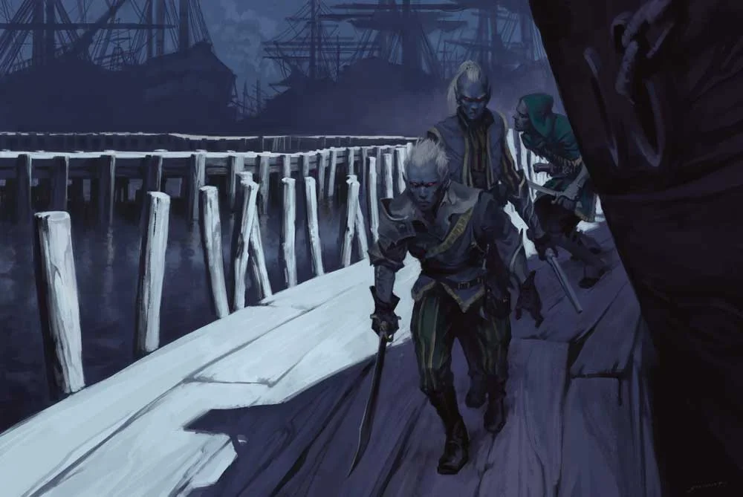

BREGAN D’AERTHE FACTION QUESTS
The factions missions for the BD are supposed to be given to a Drow player character to join their ranks, but if you can’t join them, you can still get on Jarlaxle’s good side since he is the most useful NPC ally to have. But I do recommend only using the last two missions and adding in a spicier first mission, which I have homebrewed below.
The module suggests using the 4 Faction missions for the BD, but the first two were kind of lame (fetching a handkerchief from a noble and sneaking into the Waterdeep Wazoo to deliver an expose they want planted).
Instead I came up with a true test of their loyalty: Sneaking into Zardoz Zord’s ship and stealing an eye of Golorr. This is of course, all a ruse by Jarlaxle since Zardoz has no Eye of Golorr and he is in fact, Jarlaxle. (See section on the Zardoz Betrayal Pitch for more).
The final two Faction Quests are pretty cool but are much closer to the end game and may not be necessary if you already have a lot going on with the Xanathar Guild infiltration, but you can certainly reveal that Zardoz has a spy (4th Faction Mission**) posted there when he needs to gain the party’s help and/or as a fun reveal mid-fight heel turn with Xanny if you need the tides to turn. The 3rd mission involves the defending Trollskull from waves of enemies (after JB drops off a captured member of the XG named Ott Steeltoes) and ends in a cool Beholder Zombie fight. But then again you could just have these fights in the Xanathar’s Guild in Skullport too, so they are optional.
**4th Mission as per the module:
“We have a spy deep within Xanathar's organization, but I fear he has been compromised. It breaks my heart to do this, but I'm sending you to eliminate him. Make it quick and painless, and for Lolth's sake, be discreet."
Jarlaxle identifies the traitor as a drow mage named Nar'l Xibrindas (see appendix B) and furnishes the characters with a route to Xanathar's lair through underground passageways. (Xanathar's lair is described in chapter 5. Characters who follow Jarlaxle's route arrive at area X1.) Reward: Each Bregan D'aerthe character gains 2 renown. Each party member who contributes to the mission receives a trophy bearing a gold statuette of Jarlaxle (worth 250 gp).

Part 3: Scenes He Can Be Featured In
These scenes are designed to introduce Jarlaxle as a persistent presence, not just a combat encounter waiting to happen. He should feel like someone who has already been there, already acted, and already planned for the party’s response. He’s a “force” that cannot be changed as much as you cannot or the force of gravity (unless of course you have access to 7th level transmutation 😉 )
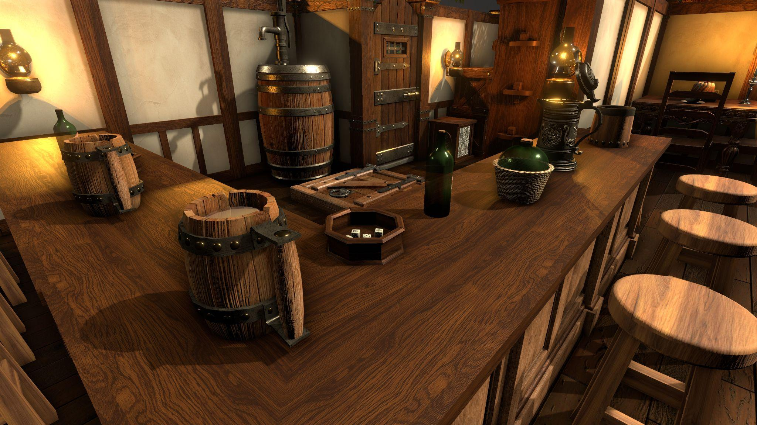

Trollskull Intro Scene
Note: This is an overview, but if you want to see an example of some dialogue and box text describing the scene of Jarlaxle when he reveals himself outside of the Trollskull, see Appendix A.
Jarlaxle sneaks into the players’ home base, ideally post-fireball. He enters Trollskull Manor when the party is tired, wounded, distracted, or separated. He waits until the house is at its most vulnerable, not because he intends violence, but because vulnerability creates honesty.
For my campaign, I chose for him to leave the Gralhund Villa battle (where he operated under a Darkness spell and only appeared as a silhouette in the darkness in the rooftop of the Villa across from the 2nd story Ballroom) when half of the party fled and began a chase scene (see my homebrew Chase Rules on DMsGuild, coming soon) with his Drow in pursuit of them. Had they been caught, Jarlaxle would have interrogated them as hostages aboard one of his ships. They managed to escape his drow elite operatives but Jarlaxle was far faster than them, easily beating them to their destination, the Trollskull.
Key elements of the scene:
- He has already been inside for some time. Any NPCs staying in the basement or upper floors have been put to sleep with sleeping powder.
  - Of course, drow like him are unaffected since they cannot sleep.
- He is comfortable. Sitting. Drinking their best wine.
  - He has slipped drow poison into this wine, as well (he is immune to this specific variant)
- He has interfered with the environment (laid traps, found escape routes, imbued an object with the darkness spell and covered it) to give him advantage.
- Nothing is broken. Nothing is stolen. Nothing can be proven.
  - In our campaign, the players hadn’t fixed the blown out windows yet, so he commented on how he didn’t break and enter, he just entered.
If confronted, Jarlaxle never escalates. He invites conversation. He reframes accusations as misunderstandings. He implies that the party’s defenses are impressive… but incomplete. They might even want to hire him as a consultant to bolster their defenses. Such things are necessary if one wishes to run a business that dabbles in adventuring.
The purpose of the scene is not merely intimidation. It is calibration. He wants to see how they respond to a crisis. Rather than rely on hearsay (even if much info has been provided by Bregan D’earthe), he wants to test the party and give them stress tests.
By the end of the interaction, the party should understand two things:
- He could have killed them and their allies (NPCs in Trollskull) he wanted to. He chose not to.
- He wants to do business with them and maybe even partner with them in the Grand Game that is unfolding.
For example dialogue that Jarlaxle might say when introducing himself, see Appendix A and for some French phrases see Appendix B.

Eyecatcher Reveal Scene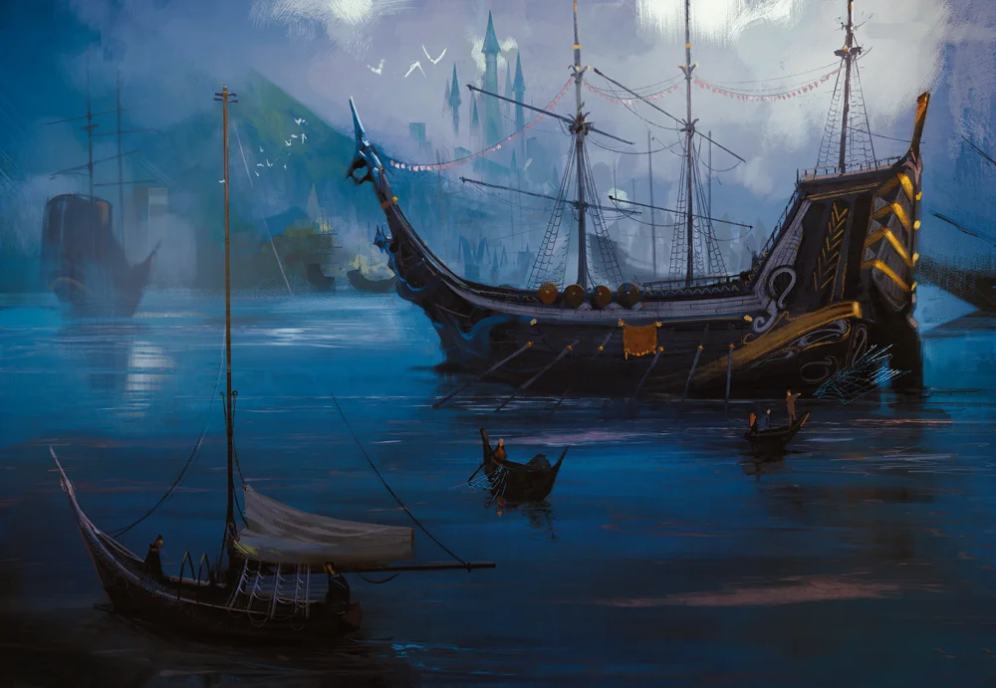
The reveal of the Eyecatcher works best when it reframes previous assumptions.
Up until this point, the Sea Maidens Faire should feel a curiosity, a background spectacle.
Secretly, this is not a carnival, this is a front for the Bregan D’earthe’s espionage, reconnaissance, and illicit trades to further the legitimization of Luskan, of which Jarlaxle is the secret lord.
You can feel free to reveal Zardoz’s true identity when you see fit, but ideally it is in a situation that Jarlaxle chooses for maximum shock value when he feels safe and has the upper hand. The spot I chose was aboard his ship. I recommend resisting the urge to reveal his identity right away unless they thoroughly unmask him with detect magic, disable his ship’s illusions, and are willing to call him out on it directly with more than a little prodding.
For specific dialogue and box text I used for my Zardoz-Jarlaxle reveal, see Appendix A.

Shipwrights’ Ball (as Zardoz)
The Shipwrights’ Ball takes place upon a massive decorated galleon that departs Mistshore and cruises around the harbor. This also puts it in close proximity to the eyecatcher at a certain point, making it a juicy opportunity for Jarlaxle to have some fun.
Jarlaxle attending the Ball will be like a kid in a candy shop. High society is where he finds a treasure trove of information. All of the passive info he has collected on nobility (through his scrying Nimblewrights) is great, but by attending parties he can act on that info, confirm its veracity, as well as plant information by spreading rumors (true or false). It’s also a chance for him to speak with those he may have difficulty arranging an audience with, such as Laeral Silverhand.
In the module (“A Night to Remember” p. 145) it suggests a secret meeting with an invisible Laeral and his 3 top spies at night, but talking as Zardoz allows him an opportunity to glean info from her and knowing Laeral, she may see through his disguise but allow him to maintain his cover. It’s canon that Harper agents have already tipped Laeral off to JB being in the city, and she has sent him a sending message for them to parlay, so it should be no surprise to her if she sees him at the ball.
During my campaign, I used the Shipwrights’ Ball as an excuse for Jarlaxle to test the players with his infamous Zardoz Betrayal Pitch (see below), where the players are tasked with sneaking aboard the Eyecatcher

The Zardoz Betrayal Pitch (Homebrew)
Because I found the first two faction missions to be a bit lame, I decided to spice things up a bit and offer the players a heist opportunity. After Zardoz heard of one of my player’s legendary run in the Arenas of Blood (Hurk’s background was a Gladiator) he sponsored the party to compete in the Field of Triumph games. So far the party likes Zardoz and wants to compete in the games, so they don’t want to get on his bad side. But they do know he sells Nimblewrights and they did some damage at the Gralhund Villa backstabbing the Gralhunds and trying to make off with the Stone of Golorr.
Jarlaxle uses this as an opportunity to test the players. He offers them a partnership in both investing in the Trollskull and finding all of the Eyes of Golorr together, and his first gift is the info that he knows where one of the eyes of Golorr is - none other than somewhere deep within Zardoz Zord’s eyecatcher.
How to Set this Up
For this ruse to work, it requires the party to NOT know Jarlaxle’s identity.
They also should NOT know that Manshoon has the final eye of Golorr.
(One eye is with the Cassalanters, one is with the Xanathar, and the final one is with Manshoon NOT Zardoz, but they don’t know that.)
What if they already know where all the Eyes are or Jarlaxle has the Stone?
If Jarlaxle already got the stone at the Gralhund Villa you can still follow my guide here, just skip the disguises and lying and have them find out Jarlaxle is attending the Shipwright’s Ball as Zardoz and have them ACTUALLY steal it from him.
If they already know where the 3 eyes are and therefore JB can’t lie about Zardoz having one, then have JB steal the stone and/or an eye from them when they return from the Gralhund villa. Again you’d want to do this when they are too exhausted to even fight back (not like JB would need the help).
I personally pointed out that Jarlaxle could have stolen the Stone from one of our players when had him one-on-one in the Trollskull when he passed out from Drow Poison but he chose NOT to as a sign of good faith.
Tip: Try reverse pickpocketing things into the players inventory to show that Zardoz can steal from them whenever he wants, almost at will. After the party agreed to potentially help him find the eyes of Golorr, the players asked him for an antidote to the drow poison. But lo and behold, he had them check their pocket - the antidote was there the WHOLE TIME. See, he’s not such a bad guy after all, right? O_o
Why would Jarlaxle try to rob himself?
There are 3 reasons why he’d do this.
- He wants to see how they respond under pressure and see their skills first hand
- He wants to see if they will be loyal to Zardoz or betray him
  - If they betray Zardoz, he will warn them not to do so again and will not trust their word in the future if they try to bullshit him about an alliance
  - If they are loyal to Zardoz, he will know they value loyalty and will applaud them for being honorable.
- He wants them to know that he is always 3 steps ahead of them. He can be anyone at any time, and if they try to betray him they’ll be sorry.
Jarlaxle can not only talk the talk but he can walk the walk. When he says he’s good at manipulating people and playing a game of political intrigue and espionage, they best believe it. He will always be in control and they will not outsmart him, and it is in their best interest to stay on his good side.
He may be an opportunist and a manipulator, but as long as they stay useful to him they have no need to worry. The enemy of his enemies is his friend, and you and him can be the best of friends if you stay on his good side. Together, he can give them wealth and he can help Luskan acquire power. A fair trade where the ends justify the means, and everybody wins.
Why would Zardoz be Jarlaxle’s enemy in the first place?
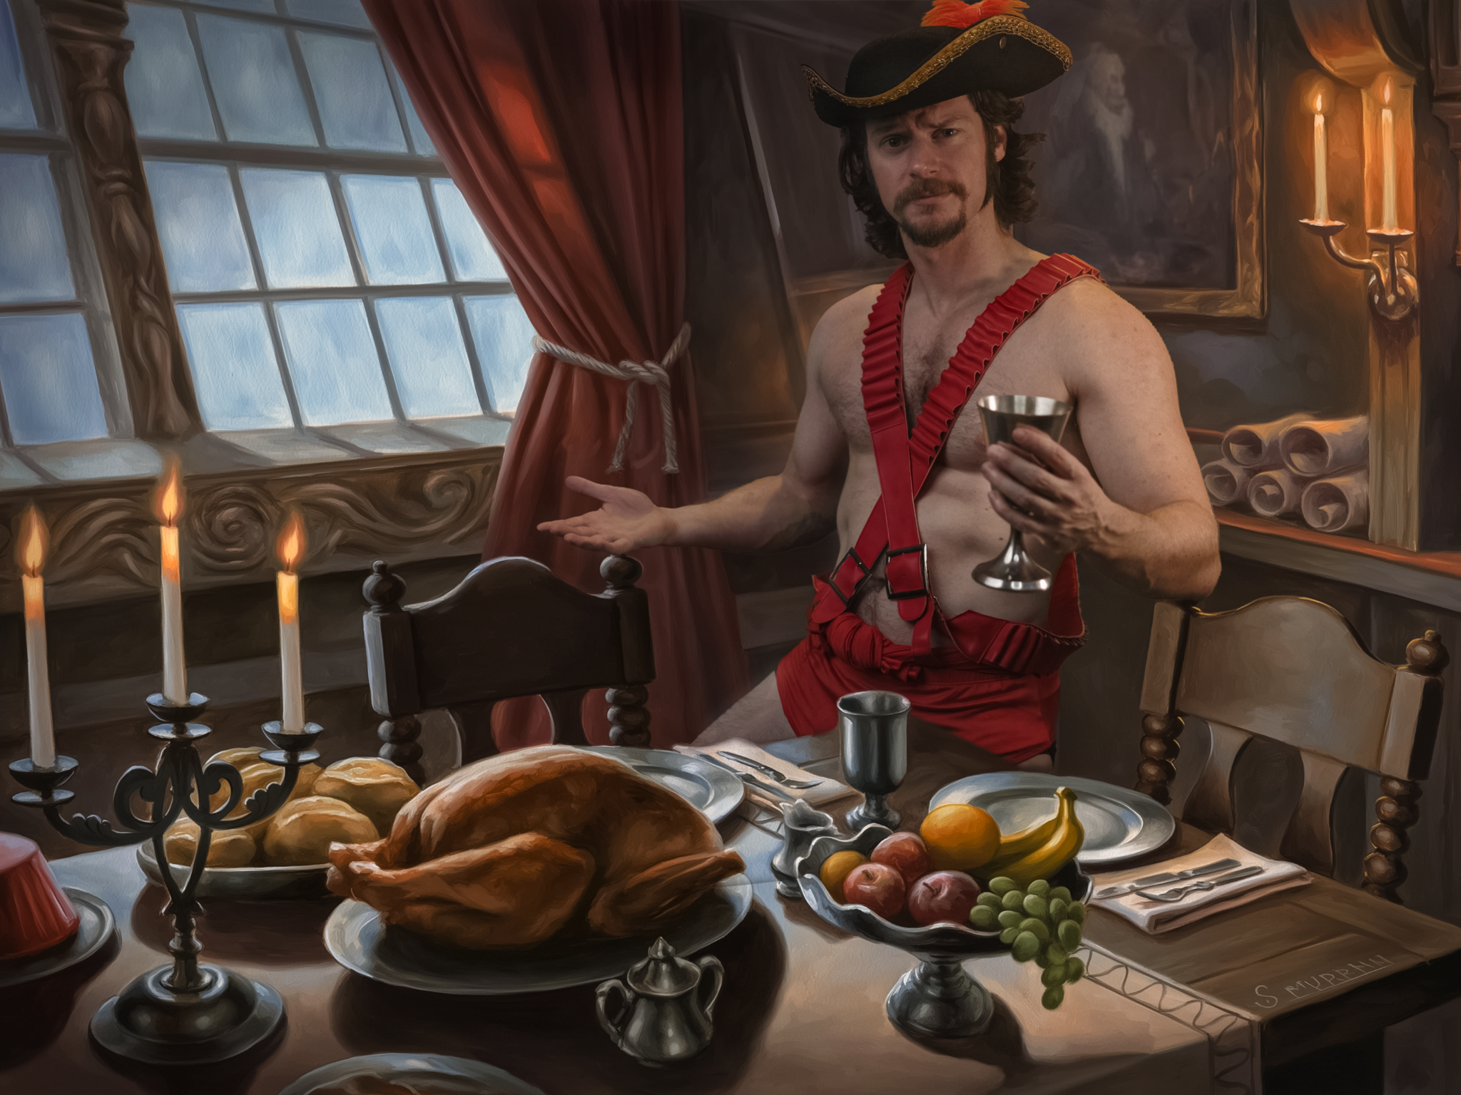
Jarlaxle tells them players a made-up story of how Zardoz is a deplorable pirate masquerading as the MC for the Sea Maidens Faire carnival. The exotic animals that the players saw in the Parade and aboard his ship aren’t the only creatures he brought. Purportedly, Zardoz is a smuggler of illegal magic items and banned exotic animals and he is selling this contraband to the Xanathar Guild.
This may or may not actually be the case depending on how villainous you want Jarlaxle to be. Jarlaxe (as Zardoz) really is trying to line up the Xanathar as a buyer for some exotic animals for the Xanathar’s bloody gladiatorial games he hosts in his lair. He already has infiltrated the Xanathar via N’arl (see below for the section on N’arl) and he wants to turn in the Xanathar to Laeral. He has even offered for N’arl to become the new operations manager for trade in Skullport as a Puppet Leader of Skullport to appeaser Laeral Silverhand.
By performing a sting operation on the Xanathar, he hopes to curry Laeral’s favor to join the Lord’s Alliance (he did not know at the time that there would be yet another opportunity with Neverember’s Enigma and the Vault). Meanwhile he can profit from the many hoarded magic items that the Xanathar has in his lair.
What is the Betrayal mission?
Jarlaxle tells the players that he knows Zardoz will be leaving his ship on the night of the Shipwright’s Ball (I made the ball conveniently begin two days later to give them time to plan and wrap things up). When “Zardoz” (secretly one of his performers in disguise) goes to the Shipwright’s Ball, the PC’s party will have a chance to sneak aboard his ship, the Eyecatcher, and look for his Eye of Golorr (the one he doesn’t actually have).
Meanwhile, Jarlaxle will be waiting with his own ship (either Big Belchy or the Scarlet Marpenoth) for when the players retrieve the stone helping them to make a getaway.
If the players refuse this offer, Jarlaxle will steal the Stone of Golorr and blackmail them into doing this job for him anyways.
If the players lie to Jarlaxle about doing the job and try to talk to Zardoz about it before the heist, Zardoz reveals himself to be Jarlaxle and congratulates them on passing the loyalty test and lets them know the location of the next Eye of your choice.
If the players succeed in getting to Zardoz’s bed chambers, Jarlaxle drops the illusions and condescendingly read them a “report card” of how well they did sneaking past his men.
Does Jarlaxle tell his crew about this fake infiltration mission?
His men may be in on the operation but are told only to raise the alarm and cast web spells but not to harm the players or risk their own lives for this silly test is playing. If you want Jarlaxle to be extra cruel you could have him only tell his gunslinger lieutenants and leave the rest of his crew to be attacked by the party, as his way of testing his own crew too to see if they are competent in defending the Eyecatcher.
Why would they become Jarlaxle’s ally after he lied to them about Zardoz?
Jarlaxle can be extremely useful to the party. Here are all the reasons why they’d want him on their side:
- If they help him he tells them they can keep the lion’s share of the gold from the Dragon’s vault. He is only interested in Laeral, not the gold dragons.
- He has reports his men have gathered on the other factions as well as blueprints with the layouts of the Xanathar’s Guild, the Cassalanter’s Villa, and the Kolat Towers.
  - He knows how to bypass the invisible wall of the Kolat Towers.
  - He knows where a secret entrance is to the Xanathar’s Guild.
  - If the team is competing in the Field of Triumph games they can compete with Zardoz as their sponsor, he can feed them insider knowledge (as well as make the creatures he supplied to the Field of Triumph gladiator games docile towards them)
  - In my homebrew, the winning team of the games is always approached by the Xanathar as potential new mercenaries and/or are offered to compete in the Xanathar’s own bloody games
- He can reward the party with magic items (See Appendix C for cool extra magic items he has from the books that are not mentioned in the module)
- If they don’t help him, they’ll have to compete against him to retrieve the stones and he could simply come back in 50 or even 100 years when they are all old, dead or gone (assuming they are not a long lived species like an Elf) and claim it later. Jarlaxle is already hundreds of years old, what’s another few centuries?
Why the Shipwright’s Ball? 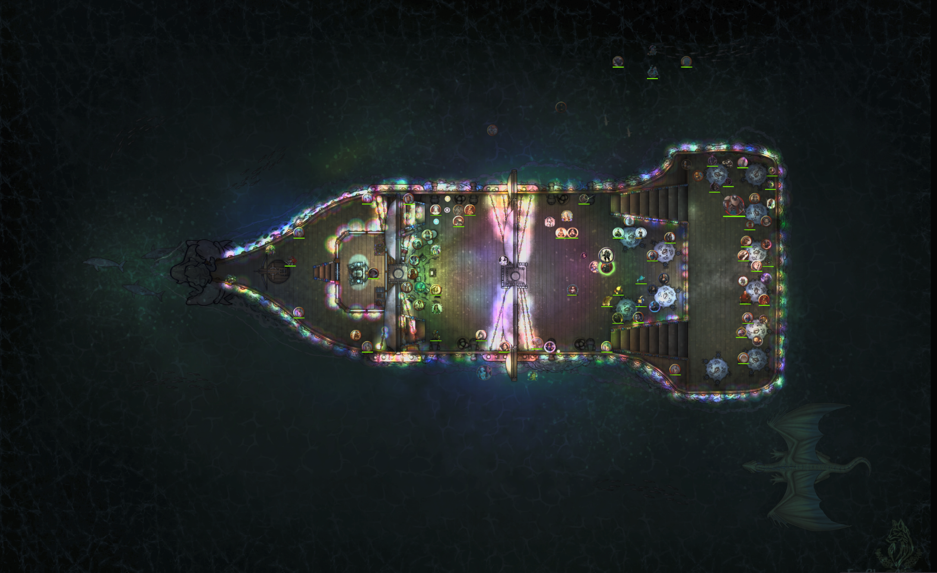
In our campaign, the Shipwright’s Ball was actually a large galleon cruise ship (see screenshot above) that departed from Mistshore and circled the Deepwater Harbor. This provides 3 opportunities:
- The players get to do another heist
- They have a reason to attend the Shipwright’s Ball and learn info from all the most important NPCs of the campaign that have gathered there, helping you advance side quests and plot hooks that may have been sidelined or stagnant
  - Don’t want to miss out on all that juicy party gossip and rumors too
- They get to meet Laeral Silverhand and Zelifarn if they haven’t already
- A unique opportunity to explore the Deepwater Harbor as it laps around it
- A chance for Jarlaxle to use his Big Belchy or Scarlet Marpenoth submarines to traverse between ships
- An excellent opportunity to split the party and learn about your players strategies that they can refine for future heists
- Gives the players without a rowboat a potential vessel (the cruising galleon) to jump off of so they don’t have to try to swim all the way to the Eyecatcher.
Where does the Ball ship go?
When the Shipwrights Ball cruise ship goes around the harbor they will do two laps, giving the players a chance to board the Eyecatcher and/or check in on their teammates if they split the party, and the final lap giving their party members a chance to get back on the cruise ship on the second lap,
It also lets the Ball Ship pass over the Dragon’s Ward so the party can speak with Zelifarn again so he can try to get the Crystal Ball back that Jarlaxle “Stole” from his mother’s hoard (this is not technically true, JB merely bought it from a Lantanese tradesman who bought it from Dragon burglars).
This also allows the players to find out about Jarlaxle’s submarine at some point. If they don’t side with Zelifarn they won’t learn of the Marpenoth docked beneath the Eyecatcher. In that case you could have the Zardoz doppelganger (one of JB’s crew dressed as Zardoz) arrive on Big Belchy and gift it to the city of Waterdeep to curry favor with Laeral who is attending the ball. Zardoz emerges from the Big Belchy ship riding his rainbow colored Diatryma in a dramatic entrance to the party after arriving fashionably late. Laeral does not know what Zardoz sounds like so the fact that his accent and mannerisms are off should alert the party that something is up.
If you want to give some credibility to Zardoz’s doppelganger but don’t want to use another disguise self spell, you might also consider making the Shipwright’s Ball a masquerade ball so his doppelganger is simply a circus performed with a mask on who Zardoz purposely disguises himself similar to in order to do this very switcheroo scenario.
Where will JB be hiding if the Zardoz doppleganger is at the Ball?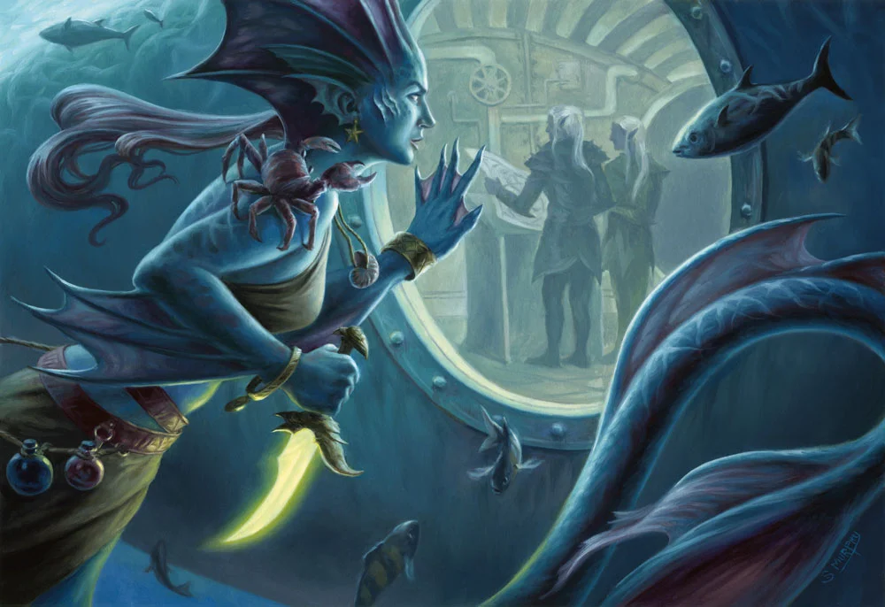
The “real” Zardoz (Jarlaxle using his hat of disguise) waits aboard the Eyecatcher. Or even better, he waits aboard the Scarlet Marpenoth submarine docked beneath it.
If the party infiltrates his ship and gets caught, he goes up and confronts them.
If the party infiltrates his ship undetected, have them go into the Marpenoth submarine (or have JB go up to his bed chambers) where they will be shocked to see “Zardoz” waiting for them. The illusion drops and Zardoz congratulates them for making it past his defenses.

Operating in Skullport: Espionage and Beyond
Skullport is an underground city on the third level of the Undermountain that Jarlaxle should feel right at home should he choose to dock there, and there’s no doubt he has in the past given the dominance of drow in that society. And yet during Dragon Heist he remains topside. However, he does have a spy amongst the Xanathar’s ranks via Nar’l Xibrindas. I would love to see Jarlaxle navigate Skullport society, and if your party decides to explore the Undermountain and/or you follow up with the Dungeon of the Mad Mage it would be fun to use Jarlaxle.
Note: I will update this section in the future with any examples and fun scenarios I dream up once our party has reached this point. For now, feel free to DM me your stories and ideas for Jarlaxle and the Undermountain.

Part 4: The Elf Killer & Soluun’s Demise

Silencing One of His Own
In our campaign the Elf Killer, Soluun Xibrindas was caught by the party and taken to the Castle of Waterdeep’s dungeon cells for questioning by the City Watch on the morrow, and the players had a narrow window to interrogate him. I homebrewed that Soluun had a visible spider bite on his neck whose rare poison left him with a unique condition where he cannot feel pain (only dull sensations).
I did this to avoid the party being tempted to torture him since that’s not a behavior I enjoy roleplaying personally, and not being able to feel pain nullifies torture tactics (which the guards posted outside the door would likely stop anyways).
Had the party been 5th level at the time our Paladin could have cast Zone of Truth, but either way this guy was not easy to break.

However, once they ask about why Soluun killed the elves, he loses his composure and preaches about his overzealous obsession with eradication the elves that he was indoctrinated in within drow society - but he also slips up that Bregan D’aerthe is not going to let elves rule above ground and that’s why he murders them. He also bears the tattoo of the Bregan D’aerthe seen below, a sigil depicting a diatryma with a spider web.
This tattoo can be found on the upper arm of any Drow Gunslinger loyal to Bregan D’aerthe. A player who passes a history check can be given a clue to remember this diatryma feather was also seen on Zardoz Zord’s crew members as his sigil. My party did not make the connection. And when they tried to reexamine the tattoo the next day it had been burned with a hot knife, creating a scar over the feather and making it difficult to make the connection to Zardoz.
Jarlaxle Kills Soluun Overnight and A Watch Captain is Framed
The players are told their time is up by interrogating the suspect and if they wish, they can observe or assist the assigned officer of the City Watch (in our case captain Jalaster Silvermane) with the formal interrogation and trial at the Halls of Justice, but the trial will not be until tomorrow. The players can also receive a small reward there if he is found to be guilty.
At this point, the players can return to their original quest giver, Davil Starsong, and collect the bounty he had placed for the Elf Killer dead or alive. However, at the Halls of Justice they find out some unexpected news. The Elf Killer was found dead in an apparent suicide in the his jail cell, but foul play was suspected but not confirmed.
The players are told that there was an officer of the watch (in this case our party’s fan-favorite Captain Kronch) who was last seen entering his cell before he was found dead. Because of this, that officer has been put under administrative leave and discretely put under a hushed form of house arrest until their name has been cleared. Secretly this was NOT that officer of the watch, but it was Jarlaxle who used his hat of disguise to put the target on another person’s back while also silencing Soluun. It pains him to kill one of his brethren, but he can’t have loose ends and he honestly is relieved to no longer have to deal with the racist loose cannon that Soluun was.
Note: My players did not elect to visit the Halls of Justice the next day. The party found this as a bit of gossip and a rumor passed along by Victor Cassalanter at their dinner that night (see my guide for setting up the Cassalanters Dinner Party here.
Another option is to simply have their newspaper delivered to break the shocking news. The Waterdeep Wazoo posts a new hot story about the Elf Killer being caught and then found killed and the story was bumped in priority to become a major headline.
Of course, the players will be highly suspicious of all this and can investigate the officer who was framed. I tried to pick an NPC they loved and Captain Kronch was the perfect target since they are less willing to believe he did it and can start a new quest to find who framed him as a continuation of the Elf Killer quest. This will inevitably lead them to Jarlaxle if they aren’t already on his trail.

Part 5: Combat and Reacting to Danger
Jarlaxle should never feel the need to fight unless something has gone catastrophically wrong. If combat begins, it is already a failure of diplomacy. Jarlaxle does not fight to win encounters, he fights to control outcomes. He never fights alone unless forced, he never fights fair, and he never stays once the odds stop favoring him.

Always have an Escape plan
Jarlaxle SHOULD be able to toy with the party, but that doesn’t mean he isn’t ready to duck out as soon as he gets what he wants. Escape methods may include:
- Darkness and invisibility (cloak of invisibility is insane, abuse this)
- Casting web to lock down any fast pursuers + Legendary Action Quick step
- Drinking a potion of Speed (my homebrew, not on his stat block by default)
- Jumping off rooftops and casting levitate
- Riding his diatryma mount that he summons with the feather in his cap
- In a pinch he can even round a corner during a chase and either:
  - Find a shadow and hide in his portable hole for up to 1 hour (air runs out)
  - Don his hat of disguise and pretend to be an NPC or a member of a crowd
    - DC 15 Perception/Insight check to notice he’s slightly out of breath
- Dropping sleep powder bombs (my homebrew) since he can’t be put to sleep
  - Obviously won’t work well against a party with elves who also can’t sleep

Combat Guide (Combos and Strategy)
Jarlaxle should always have advantage when he’s attacking and create disadvantage for enemies attacking him. This is most easily achieved with his LEGENDARY item the cloak of invisibility and the darkness spell. Do NOT forget that his burst damage comes not only from his Legendary Action to attack with his rapier/dagger x 2, but from landing a sneak attack! Which he should have every round easily if you give him advantage with being invisible.
Make sure you set up these at the beginning of combat and then plan your attacks. Jarlaxle may have high AC but that’s not enough vs the player’s action economy. He should also have minions nearby he can call on and/or that you can roll for when they show up mid-fight if he is caught alone (he’s never alone).
Also don’t forget to use his Legendary Actions to move without provoking opportunity attacks to position yourself in combat or easily flee at will while invisible.
COMBOS
- Invisibility + Attack (+ Sneak Attack!)
  - Attacking does NOT drop the invisibility
  - The only thing that breaks invisibility is using an action to remove the hood
  - Doesn’t require concentration to maintain invisibility, very broken item!
- Faerie Fire + Attack (+ Sneak Attack!)
  - Faerie fire creates a HUD-like glowing outline that paints an outline around anything or anyone trying to hide (all objects and creatures within the cube, does NOT target!)
    - It can also keep enemies from turning invisible (they disappear but the outline remains as long as concentration is kept on faerie fire)
    - It can even detect an invisible enemy if they happen to be with the 20 ft cube area of an adjacent ally
  - Be careful not to caste Darkness with his allies since it negates faerie fire
- Darkness + Portable Hole (cheesy, not recommended in combat)
  - Only use if desperate, low HP and surrounded with nowhere to flee
  - Cast Darkness, drop prone. Next round use an action to Open Portable Hole to hide in. Round 3 use final action to close portable hole.
    - Wait 30-60 minutes (no longer than a short rest, he only has an hour of air). Reappear when players have hopefully left
    - Surprise condition (2014 rules) could help offset the action he took to escape the hole still giving him a chance to escape with his Legendary Action Quickstep
Combos that don’t work:
- Faerie Fire + Darkness
  - Both spells are concentration so JB can’t cast them
  - You should still be aware of this in
  - It’s light cannot penetrate the Darkness spell (even when upcast its range would be limited for what light it did provide)
Note: The Combat strategy guide is a work in progress and David will be updating this guide as his campaign reaches an endgame where his Jarlaxle was forced to fight more and he’s had a chance to noodle on things a bit longer and playtest. Jarlaxle seems like one of the strongest villain NPCs though, so make sure you do your due diligence with him to make him more than just a flashy talker, he’s a legendary fighter too!

Part 6: Piecing it Together - Useful Info and Plot Hooks Scattered Throughout the Module
There is actually quite a bit of information on Jarlaxle, the Sea Maidens Faire, his ships, the Bregan D’earth, plot hooks that tie in well with Zelifarn, and miscellaneous bits of lore that are all scattered throughout the massive adventure text so it can be difficult to find it all in one place. Just in case you missed these tidbits, I have collected the relevant pieces of info here in one place and expanded on how to use them so you can piece it all together.

ON ZELIFARN
See my Guide to Zelifarn and the Deepwater Harbor for all the details, but basically the gist of it is that Zelifarn the Bronze Dragon was spotted in Waterdeep and Vajra wants the players to find out what it's doing there. In my campaign, I had Zelifarn searching after a family heirloom - a crystal ball - that used to be in his mother’s dragon horde, until it was stolen and sold in Lantan where Jarlaxle purchased it.
Since there is a Dragon Ward that extends halfway out to the harbor, Zelifarn cannot follow

DO I NEED TO KNOW ALL OF HIS SHIPS?
You pretty much only need to use the Eyecatcher for 90% of the module. That’s his personal flagship which has the Scarlet Marpenoth submarine attached to it, and it’s the one that’s anchored out in the Harbor for safety in case things go bad with the other ships docked in Mistshore. The other two vessels carry members of the carnival and their parade wagons and are really only useful when the party is first snooping around watching the Parade floats finish their tour of the city and get loaded into his ships. This naturally leads the players to poke around (especially if you have them do Perception and then Investigation checks on them) and this can be a great time for Zardoz to invite them to dinner aboard the Eyecatcher.

A NOTE ON SMOKEPOWDER
This is SMOKEPowder, NOT Gunpowder*. In the forgotten realms gunpowder doesn’t work. Jarlaxle’s smokepowder is different because it requires a secret ingredient to ignite (thus any smokepowder is made inert in an anti-magic field). The powder is specially prepared by the genius Lantese inventors, the same Gond-worshipping craftsman who engineered the Nimblewrights.
*Smokepowder is used to propel projectiles, typically in firearms, bombs, or cannons. Unlike gunpowder, smokepowder:
- Requires an active magical ingredient to work : Casting dispel magic on smokepowder renders it permanently inert, and like gunpowder, it will also not burn when wet.
- Is rare and valuable: Most nations restrict or regulate it due to its potential for destruction. It can only be made through a proprietary technique that Gondians know
- It is crafted by followers of Gond: Especially Lantanese inventors who blend divine power of Gond, alchemical knowledge, and engineering to produce it. Gunpowder in the Forgotten Realms does not explode, and has been banned by Ao (creator of all the Gods) and Gond.
  - But Gond has allowed Smokepowder to work because it is only his devoted worshiper who can make it by infusing it with a secret magic ingredient.
- If Smokepowder is set on fire, dropped, or otherwise handled roughly, it explodes and deals fire damage to each creature or object within 20 feet of it: 1d6 for a packet, 9d6 for a keg. A successful DC 12 Dexterity saving throw halves the damage.

USING THE GUNS
Most people haven’t heard of guns. They may have seen smokepowder canons aboard seafaring vessels but not firearms like the ones the drow gunslinger use.
If your players want to use the Gunslinger guns, I’d recommend they spend downtime on a long rest or two practicing with it to gain proficiency with them.
A packet contains enough smokepowder for five shots, and a keg holds enough smokepowder for five hundred shots.
When my players found a gun I chose to roll a 1dn+1 to (n = number of guns looted) to determine how much ammo was in the guns found on any given gunslinger.
If they want more than that they can find a huge stockpile of it hidden by Jarlaxle in the Xanathar’s Guild. (See below)
You can also find guns and powder in the safe within the Armory of the Eyecatcher, which contains three pistols, twelve leather packets of smokepowder, three leather pouches containing twenty bullets each, and 250 gp in a sack.
There are even more Smokepowder kegs in the storage room of the Hellraiser and Heartbreaker. Each has twenty wooden kegs secured to the walls with ropes.
“Each keg holds five pounds of smokepowder (see appendix A). When one keg explodes, all other kegs within the area of effect explode as well. If half the kegs explode at once, the blast blows a hole in the forward hull large enough to sink the ship. If all twenty kegs explode at once, the blast blows half the ship to smithereens, shatters windows throughout the Dock Ward, and can be heard as far away as the Field Ward.”
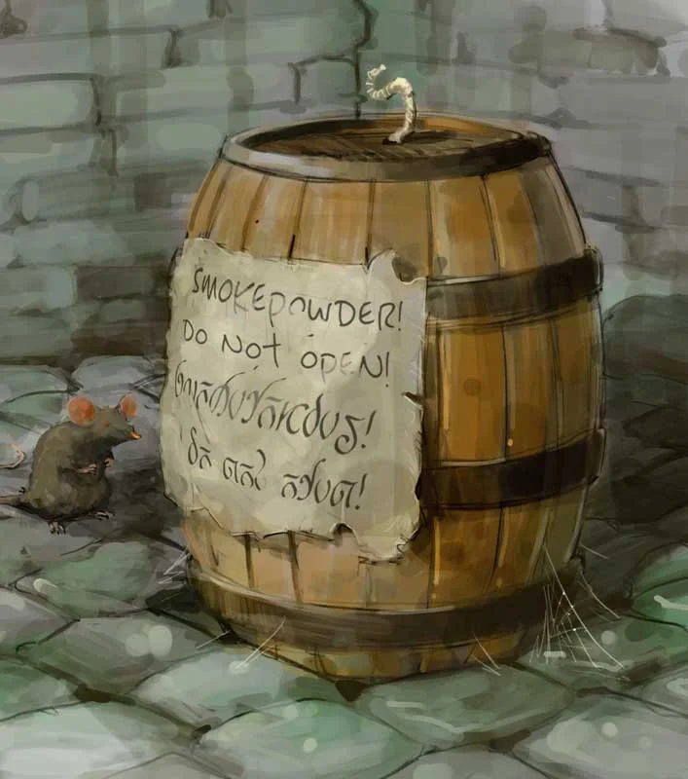

THE STOCKPILE OF SMOKEPOWDER - BLOWING UP XANTHAR GUILD
Jarlaxle’s spy Nar'l Xibrindas has smuggled smokepowder into the Xanathar’s lair in Skullport (see area X36) and, with Thorvin Twinbeard (a dwarven Harper also spying on Xanathar)’s help, he has identified areas that are structurally unstable.
If these areas all suffer catastrophic damage, the lair collapses over the course of 1 hour. Characters can learn this information by speaking to Thorvin (Xanathar’s chief engineer) in area X13.
And for those who missed it, the module DOES confirm that players CAN fit a barrel of Smokepowder into their Bag of Holding, if they have one. Nar'l borrowed Jarlaxle’s bag of holding to smuggle the kegs into the lair in the first place.

SOME N’ARLY SUBTERRANNIAN SUBTERFUGE
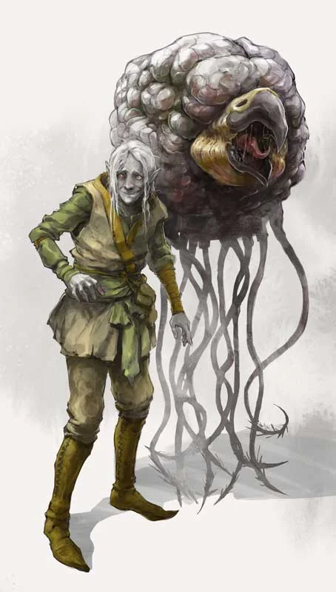
Soluun’s little bro, Nar’l, and his assigned pet Grell. Aren’t they adorable together?
Narl has been undercover for a full year and has convinced the already paranoid Xanthar to kill all of his previous advisors. But now Xanathar suspects him (rightly so) of being a spy and has assigned a Grell”bodyguard” to keep an eye on him (pun intended).
The main thing to know about N’arl is that he has a very useful poison for crippling the Xanathar, a vial containing three doses of eyescratch, a contact poison:
A creature that comes into contact with the poison must succeed on a DC 14 Constitution saving throw or be poisoned for 1 hour and blinded while poisoned in this way. A lesser restoration spell or similar magic ends the effect.
(See the Zardoz Betrayal Pitch above for why N’arl might be infiltrating the Xanathar guild in the first place).

BIG BELCHY, The Scarlet Marpenoth, and The Apparatus of Kwalish
Not sure why exactly the module gives Jarlaxle access to more than one submersible when he already has a cool state of the art submarine. But at the end of the Ch4 Chase sequence his lieutenants Fel’rekkt and Krebbyg can hop into a salvaged sub named Big Belchy. I personally think Big Belchy is better as a crappy alternative to the Apparatus of Kwalish that JB might loan out to the players or might serve as an escort if JB wants to show them the secret underwater entrance to the Undermountain to get to the Xanathar.
“A mechanical dragon turtle, dubbed Big Belchy, sank in Deepwater Harbor almost a century ago. Lantanese gnomes working for Jarlaxle have managed to repair the construct. Two rounds after the characters corner Fel'rekt and Krebbyg, Big Belchy surfaces next to the dock on initiative count 5, close enough that the drow can leap onto its barnacle-encrusted back on their next turns.
In the round after it surfaces, the mechanism breathes a cloud of steam onto the docks in a 30-foot cube, then begins to move away at a swimming speed of 20 feet. Any creature in the cloud of steam must make a DC 14 Dexterity saving throw, taking 22 (4d10) fire damage on a failed save, or half as much damage on a successful one. Big Belchy can breathe steam only once. On each of its turns thereafter, it swims a total of 40 feet toward Jarlaxle's flagship, the Eyecatcher, which is anchored in the middle of the harbor 1 mile away.
Big Belchy has AC 18, 75 hit points, and immunity to poison and psychic damage. If it is reduced to 0 hit points, it sinks once more to the bottom of Deepwater Harbor. If the drow are still on its back when it goes down, they swim the rest of the way to the Eyecatcher but gain two levels of exhaustion from the cold water and exertion.
If the drow are defeated while on Big Belchy's back, the Stone of Golorr tumbles off the mechanical dragon turtle's shell and drops into Deepwater Harbor. If the water is deep enough, the characters might need to borrow Grinda Garloth's apparatus of Kwalish to recover it.”

Why does JB want to be a part of the Lord’s Alliance?
“Jarlaxle, the leader of Bregan D'aerthe, sees membership in the Lords' Alliance as his path to power beyond Luskan. As the secret lord of a city with an unsavory reputation, he has had a hard time getting a seat at the table with other cities of the North when it comes to trade and defense of the region. Thus, he plans to use the stolen gold to bargain with Laeral Silverhand for inclusion in the alliance, and to oust Neverwinter and its lord Dagult Neverember-Jarlaxle's fiercest political opponent-from the group.”
“Jarlaxle likes to weave a tangled web of schemes that leave his enemies baffled-the latest of which is a plan to legitimize Luskan by making it a member of the Lords' Alliance. The city's unsavory reputation has thwarted all previous efforts, and the current leaders of the Lords' Alliance have voiced their opposition to Luskan's admittance. A few have flatly declared that the city will never be welcome in the alliance. Nonetheless, Jarlaxle aims to persuade Laeral Silverhand, the Open Lord of Waterdeep, to champion Luskan's cause-even if that means losing other alliance members in the process. Tying Luskan's fortunes to those of Waterdeep would increase Jarlaxle's political and economic power on the Sword Coast.”

What happens if they fight Jarlaxle and lose?
If the characters don't agree to Jarlaxle's terms, or if they assault him, he tries to knock them unconscious and leave them without clothes or equipment in a gutter in the Dock Ward. He stores their equipment in area J16 aboard the Eyecatcher, with the exception of any magic items. Those he stashes in area U4 aboard the Scarlet Marpenoth, his secret submarine.

JARLAXLE’S DISGUISES
Jarlaxle can pose as JB Nevercott, Rongquan Mystere, and even Laeral Silverhand, but the primary disguise I used was Zardoz Zord.
You can see the Module’s section “Jarlaxle in Disguise” if you want to known how Jarlaxle can pose as Laeral Silverhand to get the party to fetch the Stone of Golorr from him during the Rooftop Chase sequences of events, but since we are running the Alexandrian remix this is not something I used (although having him appear as Laeral to ask the adventurers for help is a good strategy), and they give a good reason why he needs to the adventurers to help him instead of his own men (he suspects, and rightly so, that one of his men - Nar'l Xibrindas - is a spy for the Xanathar so they can’t be trusted with this mission).
In the unlikely event that Jarlaxle is killed, Bregan D'aerthe raises him from the dead within a tenday. Once he's back in action, he tries to recover any gear that was stolen from him.

APPENDIX A: INTRO DIALOGUE - EXPLAIN THE GOALS OF BREGAN D’AERTHE
If you choose to reveal Zardoz early (aboard the eyecatcher) - or ideally, after the players have been sent on a wild goose chase to infiltrate his own ship (see Zardoz Betrayal Pitch), use this reveal (Spoken Dialogue is in Purple):
Zardoz is silent for a moment. He downs his silver goblet of wine, and stares at you as the cabin of Eyecatcher sways gently.
"Mes amis...Enough wis ze roleplaying games? I believe it is time I stopped playing pretend. Ze need for charade is over" [chuckles]
Zardoz twirls as a long cape envelopes him, and the illusion fades as his skin dyes to a deep, dark - almost black shade of purple. His ribbons of long brown hair disappear completely exposing a gleaming bald head and his ears bedazzle with earrings and sharpen to a point like an elf.
His limbs shimmer to reveal a luxurious display of vivid velvet and extravagant gold and purple silks tucked into expertly crafted but supple leather armor. A handsome, smirking drow stands before the party, his vibrant plumed hat tipped low over his brow, casting shadows across his face.
Beneath the shadows there is a gleam in his eye, like that of a cat in the dark before it about to pounce on its prey.
He pulls off the wide-brimmed hat with a dramatic flourish, bowing low with exaggerated grace. His smirk turns into a grin as he begins to speak in a refined Drow accent:
"Allow me to *properly* introduce myself: I am Jarlaxle Baenre, le légendaire! Perhaps you've heard the name whispered in shadowed halls? Perhaps not. But I assure you, by the time we are done, you will know me well."
Surely you have 'eard of me, and my résumé? My…’Curriculum Vitae’ Non?
A BIT OF SHAME…BUT NO MATTER!
You see, I once infiltrated the depths of the Underdark’s most infamous city, Menzoberranzan itself, and liberated countless slaves from beneath the noses of the most powerful drow houses. I did so, not just to weaken Lolth's stranglehold, but because I believe freedom is something we must all claim for ourselves.
But I spit in the face of Lolth. Nous sommes libres! (noo sohm leebruh → “we are free.”)
My men and I live outside her web of lies, refusing to bow before her oppressive dogma."

LUSKAN AND THE BROKEN ANCHOR
Jarlaxle describes Luskan, and why it means so much to him to curry Laeral (and the Lord’s Alliance’s) favor:
“Luskan, a city ruled by chaos and pirates. I did what no one thought possible, I brought order to that lawless place, turned it into a force, a place where men and women, drow and human alike, could carve out a destiny, outside of the reach of *either* the drow matriarchs or the surface lords."
"I made Luskan MY city, and soon, with your help, it will be *recognized* by the Lords’ Alliance."

WHAT IS BREGAN D'EARTHE
"We are drow men. Outcasts by birth, revolutionaries by choice. We defy Lolth, who would see men of our kind enslaved, powerless beneath the heels of her priestesses. But we ...WE have made our own way. WE take what is ours, not by asking, but by *force* if necessary. We carve our own future, free from the Spider Queen’s web. Our vengeance against her is just...and it shall be done by any means necessary...isn't that right <insert your party’s morally gray and/or chaotic neutral PC or Rogue>"
Help him find the Stone of Golorr
"That is who we are. And now, I offer you a place in this legend. Help me recover the Stone of Golorr, and together, we will strike down the forces that seek to use it for their own selfish ends INCLUDING the Xanathar, and anyone else foolish enough to stand in our way. We will reshape this city, and in doing so, reshape the future."
He steps back, his grin returning, his eyes dead set on yours, the deadly glare of a predator who dares their prey to flee "So, mes amis, what say you? Will you stand with Jarlaxle Baenre and ze *Bregan D’aerthe*, or will you be swept aside by those of us who dare to seize power?"
"The choice, as always, is yours. Such is what is to be free to choose, but not free of consequence"
Regarding Drow society and/or Waterdeep Blood in the Streets creating Opportunity:
"Chaos is not a Pit of despair. It is a Ladder. And I am looking for those willing to climb"

USING THE NOBILITY FOR INTEL
"Ah, mes amis," he begins with a charming grin, his French accent lilting with a playful tone. "You see, Waterdeep is a *grande dame* of a city, filled with secrets, yes, but also opportunity. The nobility... They think they hold all the cards, but they underestimate the power of a well-placed Nimblewright. C'est la vie, non? Information is the real currency in this city, and I have it in abundance."
He straightens up, walking toward the group with graceful confidence. "I have no desire to see this city fall into the hands of the Xanathar - or worse, someone who would use the treasure for… *other* purposes. The Stone of Golorr holds the key to unimaginable wealth, yes, but also to shaping the future of this city. *Rendezvous* with me, and we can seize that future together."
Pausing for dramatic effect, Jarlaxle taps the side of his goblet with a finger. "You help me recover the missing pieces of the Stone, and I will ensure that the treasure is used to unseat those who would harm Waterdeep. The Xanathar? *Un monstre*. He will be dealt with. And when Laeral Silverhand sees how I have protected her precious city from chaos, she will have no choice but to consider my *proposition* for Luskan to join the Lords’ Alliance. Imagine it: Waterdeep and Luskan, allies. *Formidable*, is it not?"
He steps closer, his voice dropping to a conspiratorial whisper. "Think of the power we could wield together. You want this city safe, and I…well, I am a businessman. *Rien ne va plus* - the dice are cast. Will you take the gamble with me, mes amis? Together, we can reshape the destiny of Waterdeep and ensure the treasure does not fall into the wrong hands. *Entre nous*, it is the smartest move you could make."
He raises his goblet once more, a sly smile curling at the corners of his lips. "To partnership, to fortune, and to the downfall of our enemies. *Santé*!"

APPENDIX B - JARLAXLE’S French PHRASES
I’ve included some common phrases that might come up when you first introduce Jarlaxle. I will update this in the future with some combat and/or fantasy specific phrases. I mostly tried to pick phrases that are common or have worked their way into the American vernacular since us Americans tend to borrow a lot of phrases from other cultures and French comes up a lot in fancy cuisines. And yet even the word cuisine, ironically, doesn’t mean what we think it means and if you struggle to pronounce these words you wouldn't be the first so I’ve included a guide for pronunciation.
- au revoir (bye), mon ami (m'friend), excusez-moi (excuse me), oui/non, merci, Voila, Je ne sais quoi, FAUX PAS (foo-pah)
- INTRO: Vis-à-vis: face-to-face, Je m'appelle, Enchante.
  - Comment ca va? (Como sa-vah?)
- FOOD: A la carte, bon appetit, la crème de la crème,
  - J’ai faim (Zhjay fah) = I'm starvin!
- COMPLIMENTS: la crème de la crème, You have quite the Resume, Touche! = To feel touched (I'm emotionally moved)
- SORRY: Mes Amis = My Friends (Meez Amee), désolée (dizz-o-lee) = sorry, C'est la vie: That's life.
  - Je suis triste (Jeu Swee Treest)
- EXCITED/Sexy: fantastique (font-asteek), C'est Super (Sett Sup-hare!) That's Great!, Au Naturale = (Natural not necessarily in the buff), double entendre, Menage A Trois
- ZARDOZ/SHIP/BALL: EN ROUTE (on rhoot), Facade (he's not what he seems), his outfit and accroutrements (tacky clothing)
- Outro: Bonne chance (Bone chonnce) Good luck!
- Miscellaneous:
  - J'en ai besoin (zhjau nee booze won) I need it
  - Peu importe (Poo ah-port) = It's not important
  - Tu plaisantes (too play-zont?) = Are you joking?
  - Ca m'est egal (Sah met ah-gal) =
  - Bien su^r = Byan soor = Of course!
  - C'est cher (say chehrr) = It's expensive
  - Bonne journée (Bone Zhjoornay) = Have a Nice Day
  - A plus tar (ah ploo tahrr) = See you later
  - Conversation (con-VERhh-sah-sean) Emphasize the VER. It's not VURR its VEHRR
  - Fesses (FESSS) or Les Fesss = Butt cheeks
  - Entree = Entrance / Grand Entrance
  - Risque = Risk-kay = Risky (technically in French it means risky not sexy)
  - Encore
  - J'aimerais (Zhjem-ah-ray) = I would like (When order, very fancy and elegant)
  - Carte blanche Cahrta-blah-nch (3 syllables)
Tips for Pronouncing the French R:
- Growl, then sigh, then do them together (and leave tongue resting behind bottom teeth and slightly touching just behind the teeth)
  - Say the word Air. Breath out but keep the tongue down and relaxed
  - The tongue touching the bottom of the teeth is common across almost all French words
  - When you pronounce a T don't let the tip of the tongue touch the top of your mouth, keep the tip glued to the teeth and let 2-3 cm behind the tip touch the roof of your mouth
French phrases and words that might be useful:
- Rendezvous (rahn-deh-voo): A meeting or appointment.
- En garde (ahn gahrd): On guard, be ready.
- Bon appétit (bohn ah-peh-tee): Enjoy your meal, but also used to mean "enjoy!"
- Coup de grâce (koo duh grahs): A final blow or act to end something.
- Fait accompli (feh ah-kahm-plee): Something already done, a decision made.
- Savoir-faire (sah-vwar fehr): Knowing how to handle yourself, sophistication.
- Faux pas (foh pah): A mistake or blunder, especially socially.
- Carte blanche (kart blahnsh): Unlimited authority or freedom.
- Touché (too-shay): Acknowledging a hit or clever remark.
- À la carte (ah lah kart): A personalized choice, picking and choosing.
- Déjà vu (day-zhah voo): The feeling of having already experienced something.
- Double entendre (doo-bl ahn-tahndr): A phrase with two meanings, often suggestive.
- C’est la vie (say lah vee): That’s life, accepting things as they come.
- Avant-garde (ah-vahn gahrd): Cutting-edge, innovative.
- Je ne sais quoi (zhuh nuh say kwah): An indescribable quality or charm.
- Laissez-faire (leh-say fehr): Letting things take their course, hands-off approach.
- Coup d’état (koo day-tah): A takeover or overthrow, perhaps used metaphorically.
- Crème de la crème (krehm duh lah krehm): The best of the best.
- Par excellence (pahr ek-seh-lahns): By definition, the best example.
- S’il vous plaît (seel voo pleh): Please.
- Merci beaucoup (mehr-see boh-koo): Thank you very much.
- Ménage à trois (meh-nahzh ah twah): A trio, often playful or suggestive of an alliance.
- Tête-à-tête (teht ah teht): A private conversation.
- En route (ahn root): On the way.
- En vogue (ahn vohg): In style or fashionable.
- Bête noire (beht nwahr): A personal nemesis or something particularly disliked.
- Pièce de résistance (pyehs duh ray-zee-stahns): The most important or impressive thing.
- Nouveau riche (noo-voh reesh): Newly rich, often implying showiness.
- Bon voyage (bohn vwa-yahzh): Have a good trip.
- Chic (sheek): Stylish, fashionable.
- Risqué (ree-skay): A little bit daring or provocative.
- Nom de plume (nohmm duh ploom): A pseudonym or pen name.
- Tour de force (toor duh fors): An impressive achievement or feat.
- Au contraire (oh kohn-trair): On the contrary.
- Entrepreneur (ahn-truh-pruh-nur): A businessperson, risk-taker.
- Protégé (proh-teh-zhay): Someone under one’s protection or mentorship.
- Mise en place (meez ahn plahs): Everything in its place, often for preparation.
- Vis-à-vis (vee zah vee): In relation to, face to face.
- Finesse (fee-ness): Skill and grace in dealing with situations.
- Bon mot (bohn moh): A witty or clever remark.
- Risqué (ree-skay): Suggestive or daring, often referring to humor or style.
- Ensemble (ahn-sahm-bluh): Together, as a group.
- En passant (ahn pah-sahn): In passing, a brief mention.

APPENDIX C - MAGIC ITEMS
If attunement weren’t a thing, Jaraxle would be crazy overpowered. But I think knowing his full list of items is cool if has time to prepare (like you do as a DM when you know what he might be facing) so I say keep some of these at the ready. Heck you could even show these to the players and Jarlaxle can try to bribe them to do a job for him where he’ll let them pick an item out from his bag of goodies.
Lucky for us there’s a fellow Reddit user who has already compiled all of the magic items mentioned in the books. I’ve added my own notes on uses at the end of each entry.
JARLAXLE MAGIC ITEMS (Reddit post)
- RING OF SPELL STORING (5 levels worth of spells)
  - Hold Person (Lv 2)
  - Haste (Lv 3)
  - Suggestion (Lv 2)
  - Hypnotic Pattern (Lv 3)
    - If I had to pick two of these to fill the 5 levels it would be Suggestion + Hypnotic Pattern
    - Both spells are good for crowd control or to influence a PC
    - Buuut Haste allows him to style on people when combined with Legendary actions
    - Hold Person would also be funny for that player who tries to interrupt his monologues )
- Ring of Protection
- Ring of Fire Resistance
- Ring of Telekinesis
- Ring of Regeneration
PC Friendly (Censored) View of Rings:
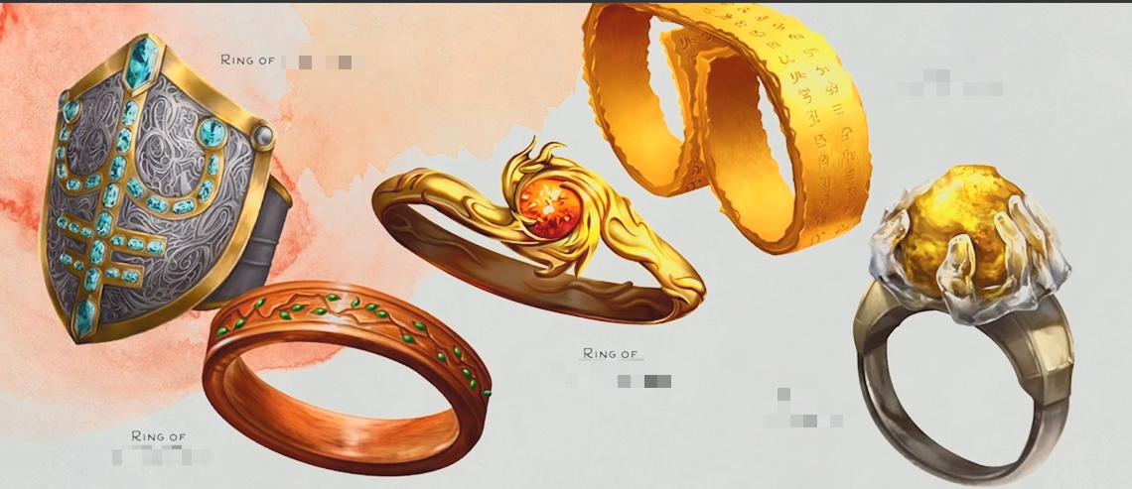
From Left to Right: Protection, Regeneration, Fire Resistance, Spell Storing, Telekinesis
Grappling Hook Earring
- The Grappling Hook Earring appears to be a standard grappling hook, however it is small enough to fit in your ear. While holding the earring, you may use an action to will the earring to grow to the size of a normal grappling hook or back to wearable size.
- Use this if he ends up in an anti-magic field and can’t use his levitate spell, or just to look cool jumping off a rooftop and swinging using this, or lend it to a PC who can use it to rappel down a building in a heist

X-Ray Eyepatch of Mind Blank
The X-Ray Eyepatch of Mind Blank appears to be a normal black silken eyepatch, however it has two effects when worn over either eye.
When worn over the left eye, you will have the ability to see through barriers thinner than 1 foot of stone, 1 inch of common metal, a thin sheet of lead, or 3 feet of wood or dirt.
While worn over the right eye, you are permanently under the effects of the spell Mind Blank.
Blurred Piwafwi (Rainbow Cloak)
The Blurred Piwafi is a shimmering, multi-colored cloak that seems to displace light. While wearing the Piwafwi, ranged attacks from more than 30 feet against you are rolled with disadvantage.

Brooch of Shielding (Counterspell)
The Brooch of Shielding is a Silver brooch with a sapphire gem set in the center. The Brooch has 8 charges.
While wearing the brooch, if a spell targets you or has an area of effect that includes you, you may cast the spell Counterspell without using any spell components.
When you do so, subtract a number of charges equal to the spell level of the spell cast against you. If the brooch reaches 0 or fewer charges, roll 1d20.
On a result of 1-4, the brooch melts and is forever lost. Each day at sunrise, the brooch recovers 1d4-1 (0-3) charges.

Drow Noble Brooch (Levitate on Reaction)
The Drow Noble Brooch is an adamantine spider-shaped brooch with two triangle cut rubies inlaid end-to-end. While attuned to and wearing the brooch, you may use your reaction to cast the spell Levitate on yourself without using any spell components.
Each activation of the brooch uses 2 charges and the brooch has a maximum number of charges equal to your character level. Each morning at sunrise, the brooch recharges 1d4 charges.

Mirror Image Ring
The Mirror Image Ring is a gold ring inset with a reflective piece of polished metal. While wearing the ring, you can use an action to speak a word of power to activate the ring's magic and cast the spell Mirror Image on yourself, without using any components. The ring may be used in this way once per day and the ring regains its charge each morning at sunrise.

Ring of Teleport
The Ring of Teleport is a silver ring inset with an Amethyst gem. While wearing the ring, you can use an action to speak a word of power and cast the spell Teleport on yourself without using any spell components. Once used this way, the ring becomes dormant and can be used again after dawn in 1d4 days.

Wand of Lightning Bolts
The Wand of Lightning Bolts is a slender steel wand, blackened at one end. The wand has 9 charges and while you hold it, you can use an action to cast the following spells without any components:
Lightning Bolt as if you used a 3rd-level spell slot, using 3 charges
Chain Lightning as if you used a 6th-level spell slot, using 6 charges
The wand regains 1d4+1 expended charges each day at dawn. However, if you expend the wand's last charge, roll a d20. On a 1, the wand crumbles to dust and is destroyed.

Wand of Illusory Fire(Ball)
The Wand of Illusory Fire is a blackened wooden wand that constantly smokes and smolders, emitting a very faint glow. While you hold this wand, you can use an action to expend 3 of its 6 charges to cast the Fireball spell without using any spell components.
Each creature within the range of the fireball blast must make a Wisdom saving throw instead of Dexterity. A creature that succeeds on the saving throw, that is immune to illusions, that can see the true nature of illusions, or that know the nature of the wand take no damage instead of half damage. The Illusory fire does not ignite flammable objects.
The wand regains all expended charges at dawn 1d4 days after its last use. However, if you expend the wand's last charge, roll a d20. On a 1, the wand crumbles to dust and is destroyed.

Drow Sleeping Poison
Drow Sleeping Poison is a rare and insidious concoction brewed from a selection of ingredients only found in the lower underdark. You may use an action to apply poison to your next weapon attack or 3 pieces of ammunition. The poison, once applied, retains its potency for 1 minute.
When you do damage to a creature with a weapon or piece of ammunition coated in the poison, roll 5d8. If the creature has fewer hit points than the total, they immediately fall asleep for 1 hour. This poison is cumulative and remains in a creature's system for 1 hour, each attack increases the total to compare against. Creatures resistant to poison are affected by half and creatures immune to poison are unaffected. Creatures immune to magical sleep are not immune to the effects of this poison.
Wand of Glue (Web)
The Wand of Glue is a sticky, wooden wand. While you hold the wand, you can use an action to expend 2 of its 6 charges to cast the Web spell without using any components.
The effect of the wand differ from the Web spell in that instead of webbing, the substance is a green sticky goo and it does not catch fire. A creature caught in the goo can use its action to make a Strength check DC 14 to escape. The wand regains 1d4-1 expended charges each day at dawn. However, if you expend the wand's last charge, roll a d20. On a 1, the wand crumbles to dust and is destroyed.

Ring of Portals
The Ring of Portals is a wooden ring with a strip of steel banded around one end. While wearing the ring, you may use an action to cast the spell Dimension Door without spell components by speaking a word of power. Once used this way, the ring becomes dormant and can be used again after dawn in 1d4 days.

Ornamental Dragon
The Ornamental Dragon is a silvery palm-sized statuette of a dragon of indeterminate chroma. It is rearing, with its wings spread and jaw open. Once per day using an action, it may be activated by speaking a word of power. When you do so, roll 1d10. The result of that roll determines the color the statue turns and the type of breath weapon it uses.
- Black, Acid Damage, 5 by 30 ft. line (Dex. save)
- Blue, Lightning Damage, 5 by 30 ft. line (Dex. save)
- Brass, Fire Damage, 5 by 30 ft. line (Dex. save)
- Bronze, Lightning Damage, 5 by 30 ft. line (Dex. save)
- Copper, Acid Damage, 5 by 30 ft. line (Dex. save)
- Cold, Fire Damage, 15 ft. cone (Dex. save)
- Green, Poison Damage, 15 ft. cone (Con. save)
- Red, Fire Damage, 15 ft. cone (Dex. save)
- Silver, Cold Damage, 15 ft. cone (Con. save)
- White, Cold Damage, 15 ft. cone (Con. save) The breath weapon color, shape, and type are determined after you aim and deals 5d6 damage on a failed saving throw or half on success.

Flat Bat
The Flat Bat is a bat-shaped piece of fabric. While attuned to the Flat Bat you can use an action to cast the spell Find Familiar without using any spell components and to transform it into the facsimile of a real bat. You may end the spell as an action or the spell ends automatically after 1 hour, and the Flat Bat transforms back into fabric. Once the spell ends, Flat Bat becomes dormant and can be used again after dawn in 1d4 days.

Tablecloth of Heroes' Feast
The Tablecloth of Hero's Feast is a 6 foot square red and white plaid and block patterned tablecloth. Once per week using an action, you can speak a word of power to activate the cloth. When you do so, the cloth begins to float as if it were lying on an invisible table. Upon the cloth, the spell Heroes' Feast is cast without using any spell components.

Whistle of Knocking
The Whistle of Knocking is fashioned from silver and hangs on a long silver chain. You may use an action to blow through the whistle to produce any one of the following effects:
- Cast the spell Arcane Lock without using any spell components
- Cast the spell Knock without using any spell components
- Instantaneously cause an unlocked door or window within 30 feet to fly open or slam shut
- Produce a whistling sound that can be heard by only one creature that you can see After using the whistle, it becomes dormant and cannot be used again for one hour.

Ruby Pendant of Beguiling
The Ruby Pendant of Beguiling is a large, multifaceted ruby that hangs from a gold chain. You can use an action to spin the pendant and cast the spell Charm Person without any using spell components against a creature within 10 feet that can see it spinning. The spell level of the Charm Person effects may be as high as your Charisma modifier.

APPENDIX D: JARLAXLE STAT BLOCK
This section is a work on progress. I suggest you utilize Jarlaxle’s magic items to the fullest and make sure you understand just how good his legendary items are like his cloak of invisibility. I would also recommend giving him some of the enhanced reactions granted by the items in the magic items he has in books. One in particular is using Levitate as a reaction using the Drow Noble Brooch to save him from a fall. (And this is a free spell not requiring a spell slot to cast when it is cast on Jarlaxle according to his stat block, so it is like a better version of feather fall).
I will be updating his stat block over the next week after I release this guide so stay tuned! For now here is a cleaned up version of his stat block we can make some notes on later:
Ways I enhanced his stat block:
<this is a work in progress, I will be updating this in the future>
Firstly, we are allowing JB to bypass even further beyond his Master Attuner. After all, his 5 rings on one hand alone will already hit this limit, so we will allow him to use these rings in addition to what is equipped in his stat block.
(Actually, one of those rings - the Levitation one - is already accounted for in his stat block with his 1/day Levitation spell).
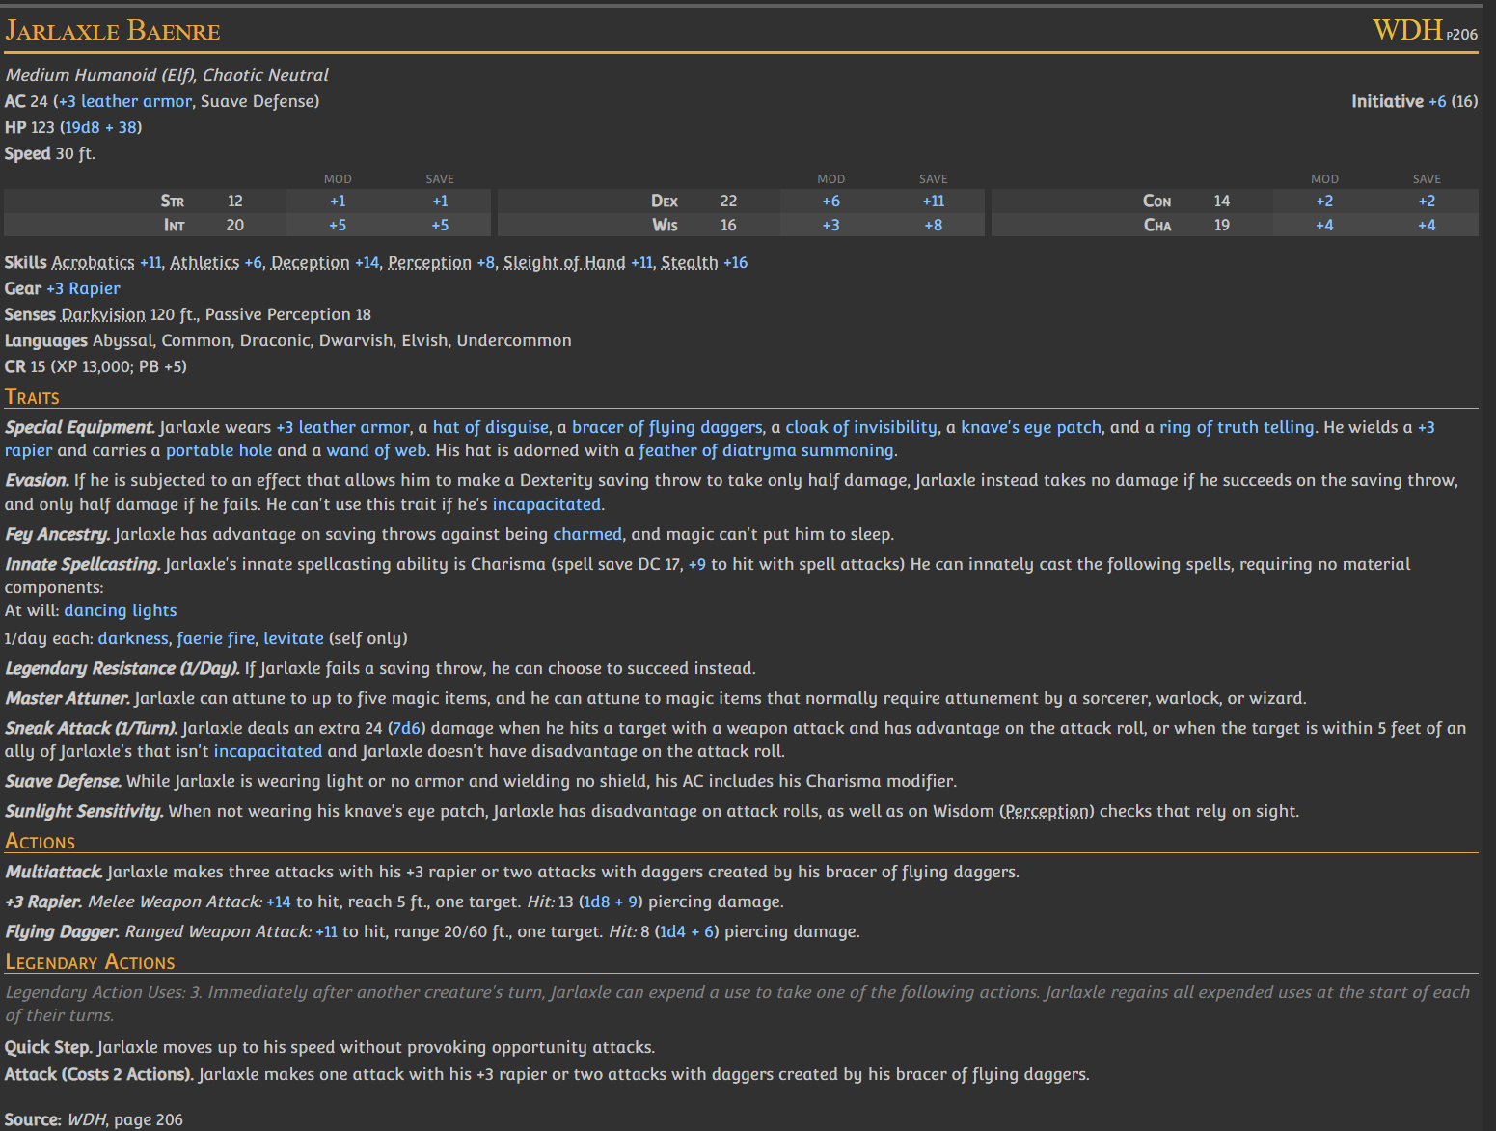
Using his special equipment & abilities to create fun RP moments:
- His smokepowder kegs have been slipped into the Xanathar Guild hideout to blow the place sky high. Use all of them or some of them in strategic spots to sew chaos and cause a distraction or in battle while JB is infiltrating the XG.
  - If Smokepowder is set on fire, dropped, or otherwise handled roughly, it explodes and deals fire damage to each creature or object within 20 feet of it: 1d6 for a packet, 9d6 for a keg. A successful DC 12 Dexterity saving throw halves the damage.
- His wand of web should be used to catch adventurers from trying to run away from him.
  - This goes along well with his sigil (also tattooed on his gunslingers) which is a diatryma feather on a dark purple spider web.
- Feather of Diatryma (note that a Diatryma is basically the same thing as an axe beak and their stats blocks in 2025 are identical)
  - Use him for mounted combat to give him 50 feet per round
  - It is supposed to be a colorful bird akin to a giant peacock which suits Jarlaxle's flamboyant peacocking perfectly
- The man can cast levitate at will!
  - Sure it's only on himself but this is extremely useful for espionage and makes no tower or stronghold safe from him
  - He is also really hard to kill by throwing off a ledge and he can escape any situation simply by jumping off a ledge
  - My personal touch:
    - He can also cast Levitate as a Reaction if he still has a Legendary Action remaining, but it costs all 3 Legendary Actions to perform
    - This prevents you from using 1 of the LA to flee with his bonus movement while he is levitating to escape (that’s too much IMO)
- Knave Eyepatch + Ring of Truth telling = He detects your lie, and you detect nothing
  - Eyepatch: "You are immune to magic that allows other creatures to read your thoughts or determine whether you are lying. Creatures can communicate telepathically with you only if you allow it."
  - Ring: While wearing this ring, you have advantage on Wisdom (Insight) checks to determine whether someone is lying to you.
  - An astute player who has Detect Thoughts on Zardoz or Jarlaxle should be baffled by the silence they hear which adds to the unease
- Know Thy Enemy
  - If he spends 1 minute or longer talking to someone his Knave Eyepatch also lets him partially see through their disguise self, with subtle shimmering waves of light refracting to reveal small tufts of hair, fur, tusks, and other features that can only be seen with a concentrated effort

Hey there, you’ve reached the end of the guide for now!
Special thanks to the Waterdeep Dragon Heist subreddit for showcasing how cool Jarlaxle could be, especially ShadowKat’s Jarlaxle guide which really helped me learn his background before homebrewing my own version of this iconic guy. You can find her guide HERE.

